INFO 7290 (DWBI): HW03a – Bulk Copy Out

Smit Patil

Input commands:

* bcp sales out d:\Northeastern\DWBI\Week02\salesout.csv -S smit-pc -d pubs -T

Generated with the prefix of 0, field type: char, terminated by comma(,) and \n for end of record

* bcp sales out d:\Northeastern\DWBI\Week02\salesout.csv -S smit-pc -d pubs -T -f salesout.fmt
* bcp sales out d:\Northeastern\DWBI\Week02\salesout.txt -S smit-pc -d pubs -T -f salesout.fmt

Screenshot of working bcp commands in command promt:

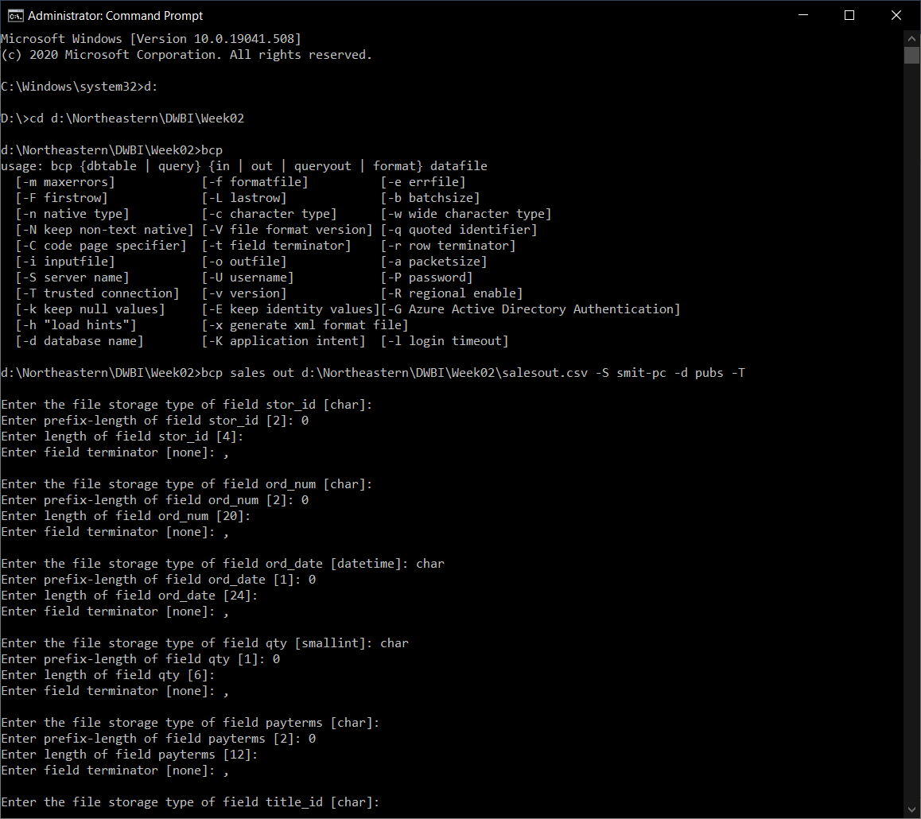

Cont:

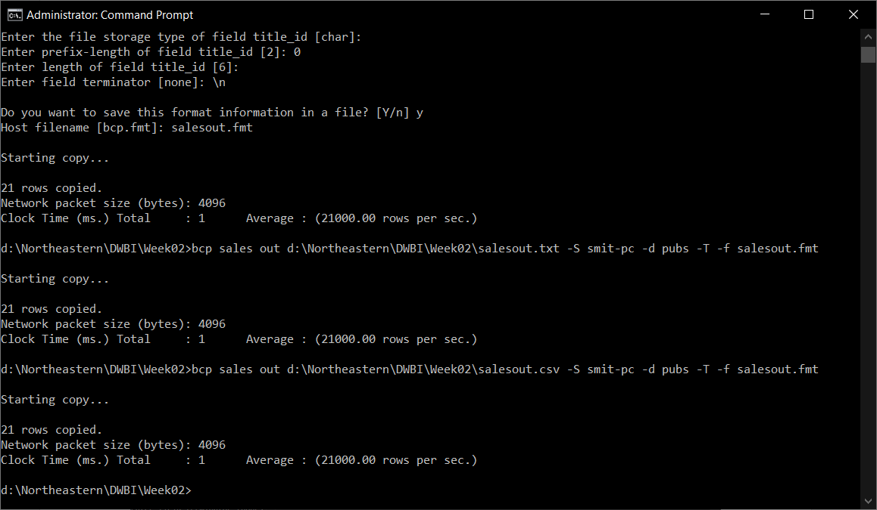

Screenshot of format file (salesout.fmt):

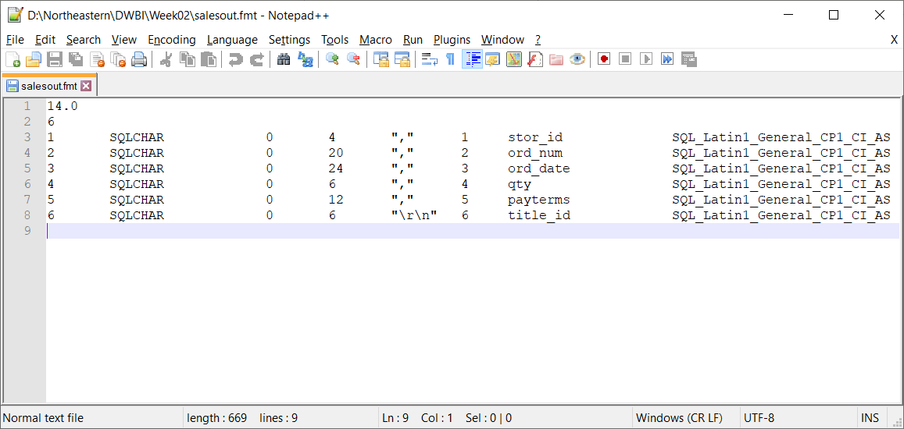

Screenshot of sales output csv file (salesout.csv):

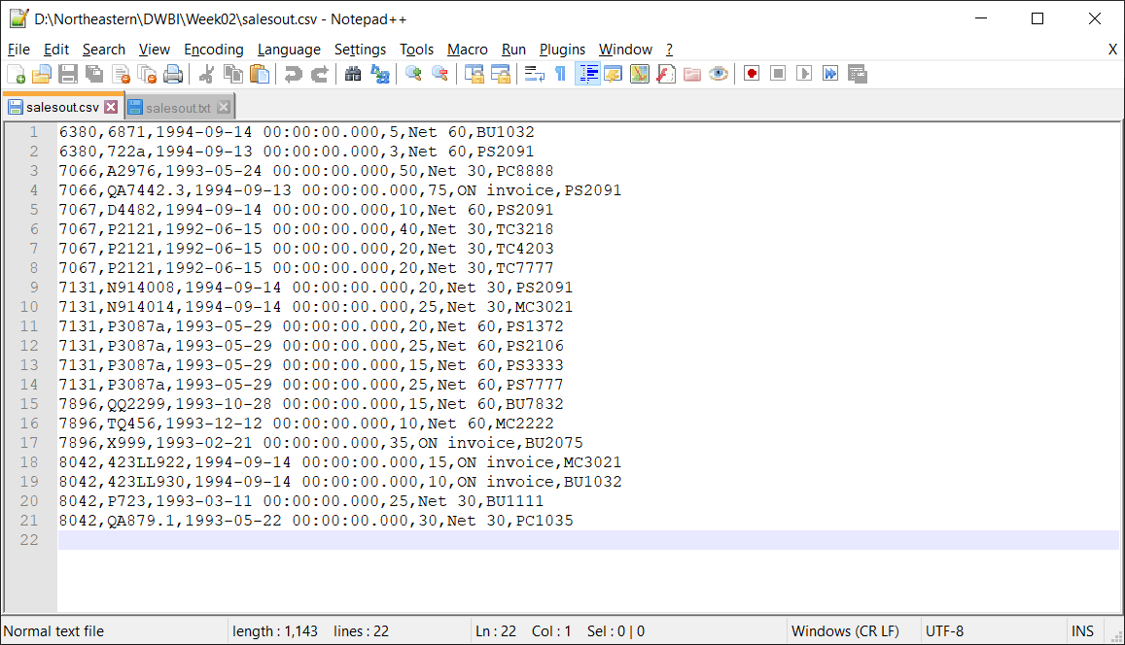

Screenshot of sales output text file (salesout.txt):

